EMPLOYMENT OPPORTUNITY – Halifax, NS

Return to Work Assistant
12- & 18-Month Term Opportunities Available

About Us
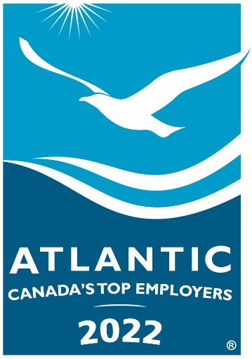
WCB Nova Scotia is the province’s provider of workplace injury insurance.

Our vision is a Nova Scotia safe and secure from workplace injury.

Our first priority is always injury prevention. But when injury occurs, we support workers to recover safely while working, or to return to work in a safe and timely manner. We also provide extended benefits in cases where the person is no longer able to work due to their workplace injury, and we support families in the wake of workplace tragedy.

WCB Nova Scotia is consistently recognized as a Top Employer in Atlantic Canada and in Nova Scotia, and has been recognized nationally as a Top 100 Employer and as one of Canada's Most Admired Corporate Cultures.

About the Opportunity

The WCB is seeking energetic and adaptable individuals with a strong administrative background to join our Integrated Services Teams.

Reporting to the Manager, the Return-to-Work Assistant collaborates with a case management team to support those injured at work and, where possible, support their safe recovery while working. You also support the worker’s overall safe and timely return to work.

As a Return-to-Work Assistant, you are an important member of the case management team. Your work is primarily administrative, assisting workers, case workers, employers and service providers throughout the course of supporting recovery from a workplace injury. This includes responding to general inquiries regarding claim status and assisting case workers in activities and plans that support the injured worker’s recovery. Other important tasks include entering relevant data into the system to set benefit rates, processing a range of requests while following established processes and procedures, as well as using Microsoft Office Suite and a claims management system.

About You

If you are a motivated and experienced professional with strong accuracy, organizational and adaptability skills, this may be the position for you. The successful candidate will be someone who thrives on working in a fast-paced environment and works well both independently and as part of a team.

As the ideal candidate, you possess
- 1 year college diploma in business or office administration or a related discipline
- Minimum of 1 year experience working in a customer service environment
- Demonstrated experience working with computer software programs in a customer service environment
- Previous work experience in a public or private insurance, medical, safety or other related environment is an asset

As safety champions, all employees are responsible for following safe work procedures; using personal protective and safety equipment as required; knowing and complying with all regulations; reporting any illness or injury immediately to their manager; reporting unsafe acts and unsafe conditions; and cooperating with occupational health and safety initiatives. We are a scent-reduced environment. WCB also promotes a diverse and respectful workplace.

We offer a competitive compensation package including a salary range of $42,156 – $52,695

How to Apply
Please email your resume and cover letter as one document with your name and the job title Return to Work Assistant in the document title (Microsoft Word format) to hrdept@wcb.ns.ca by 4 pm, September 16, 2022.

In the subject line of your email, please quote competition number: 81-22 EXT Return to Work Assistant.

We thank all candidates for their interest. Only those selected for interviews will be contacted.

Any offer of employment will be conditional upon the completion of all applicable background checks and confirmation of credentials, the results of which must be satisfactory to the employer.

The WCB is an equal opportunity employer committed to supporting and developing our employees. Visit our website at www.wcb.ns.ca.

